**Google Client Id and Client Secret Creation:**

Login to <https://console.cloud.google.com/>

Select My First Project Drop Down

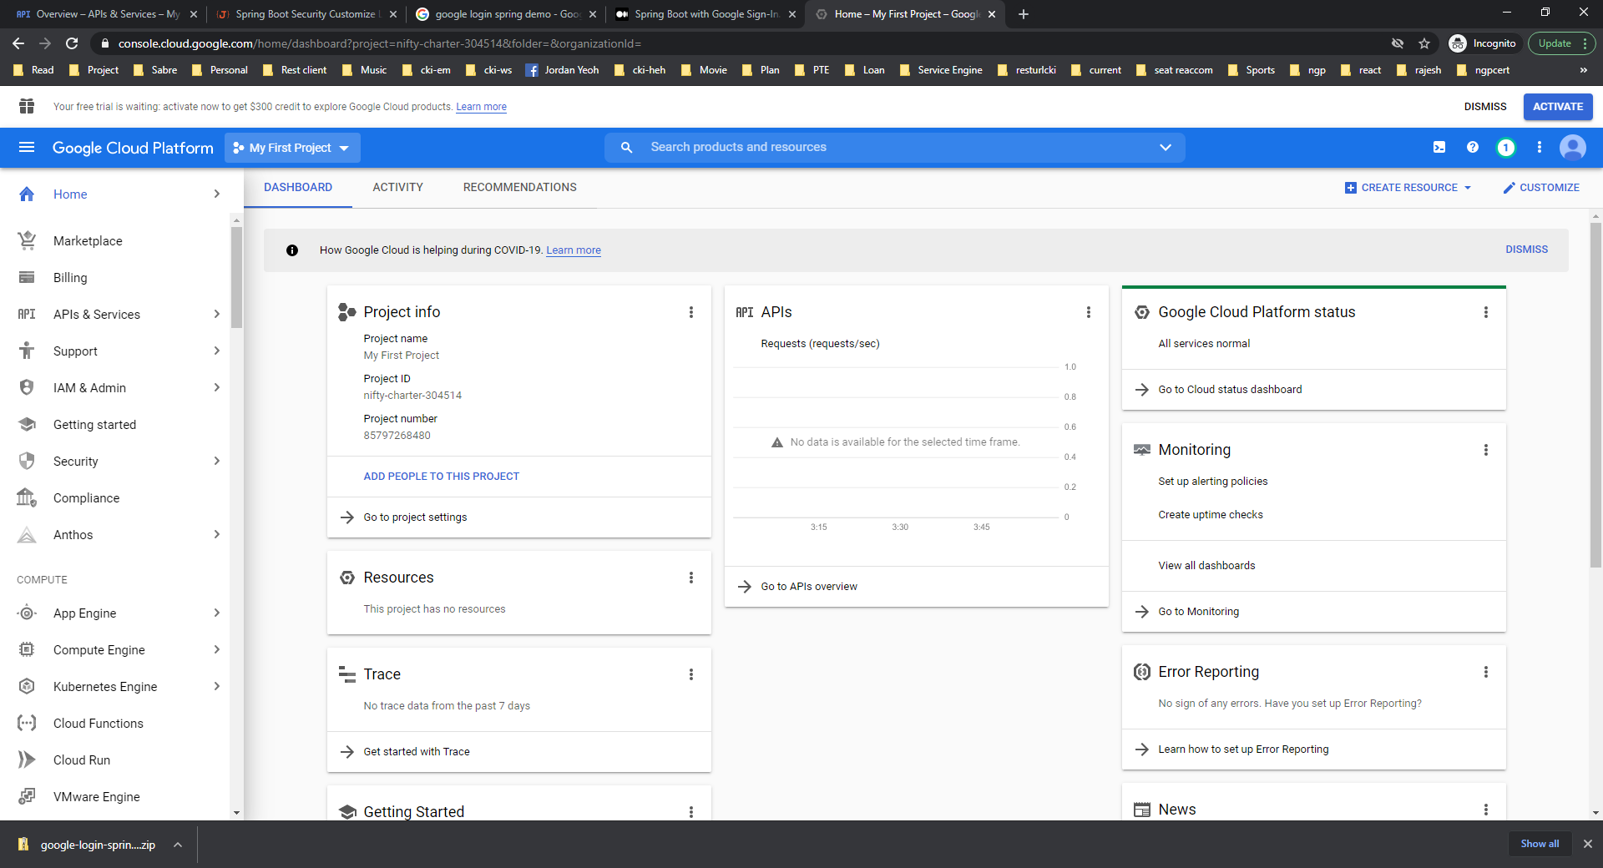



Click New Project

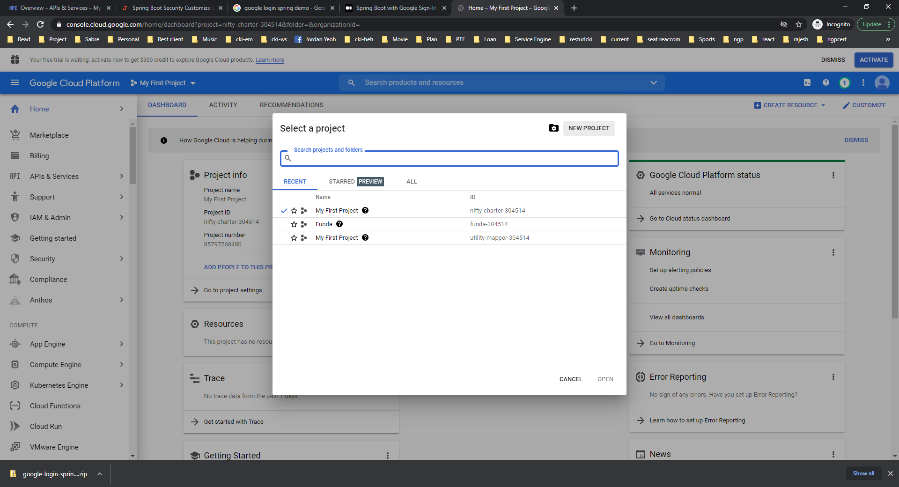



Give Your Project Name and Organization (Optional which is not require). Then Create.

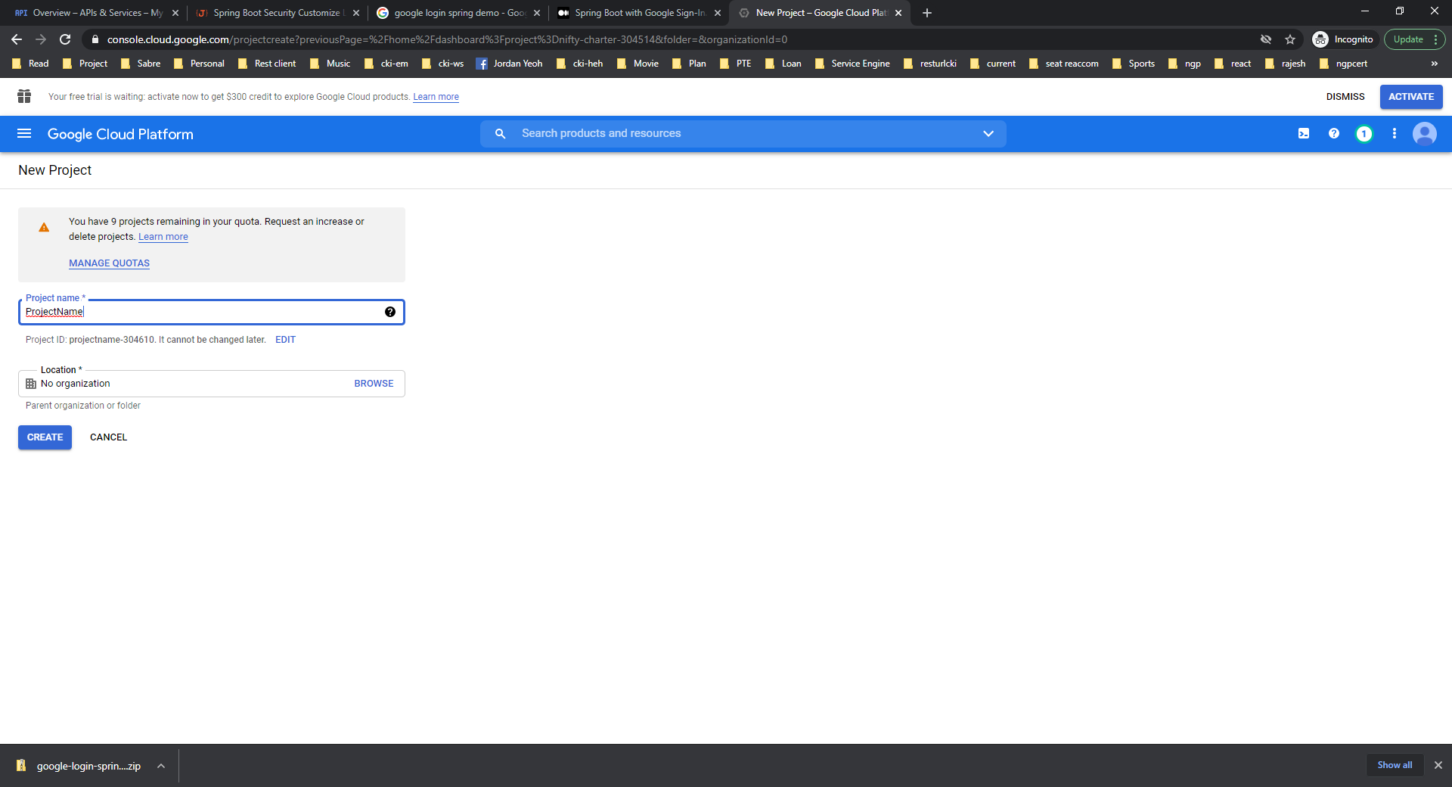

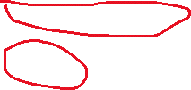

Once New Project created Select the same Project.

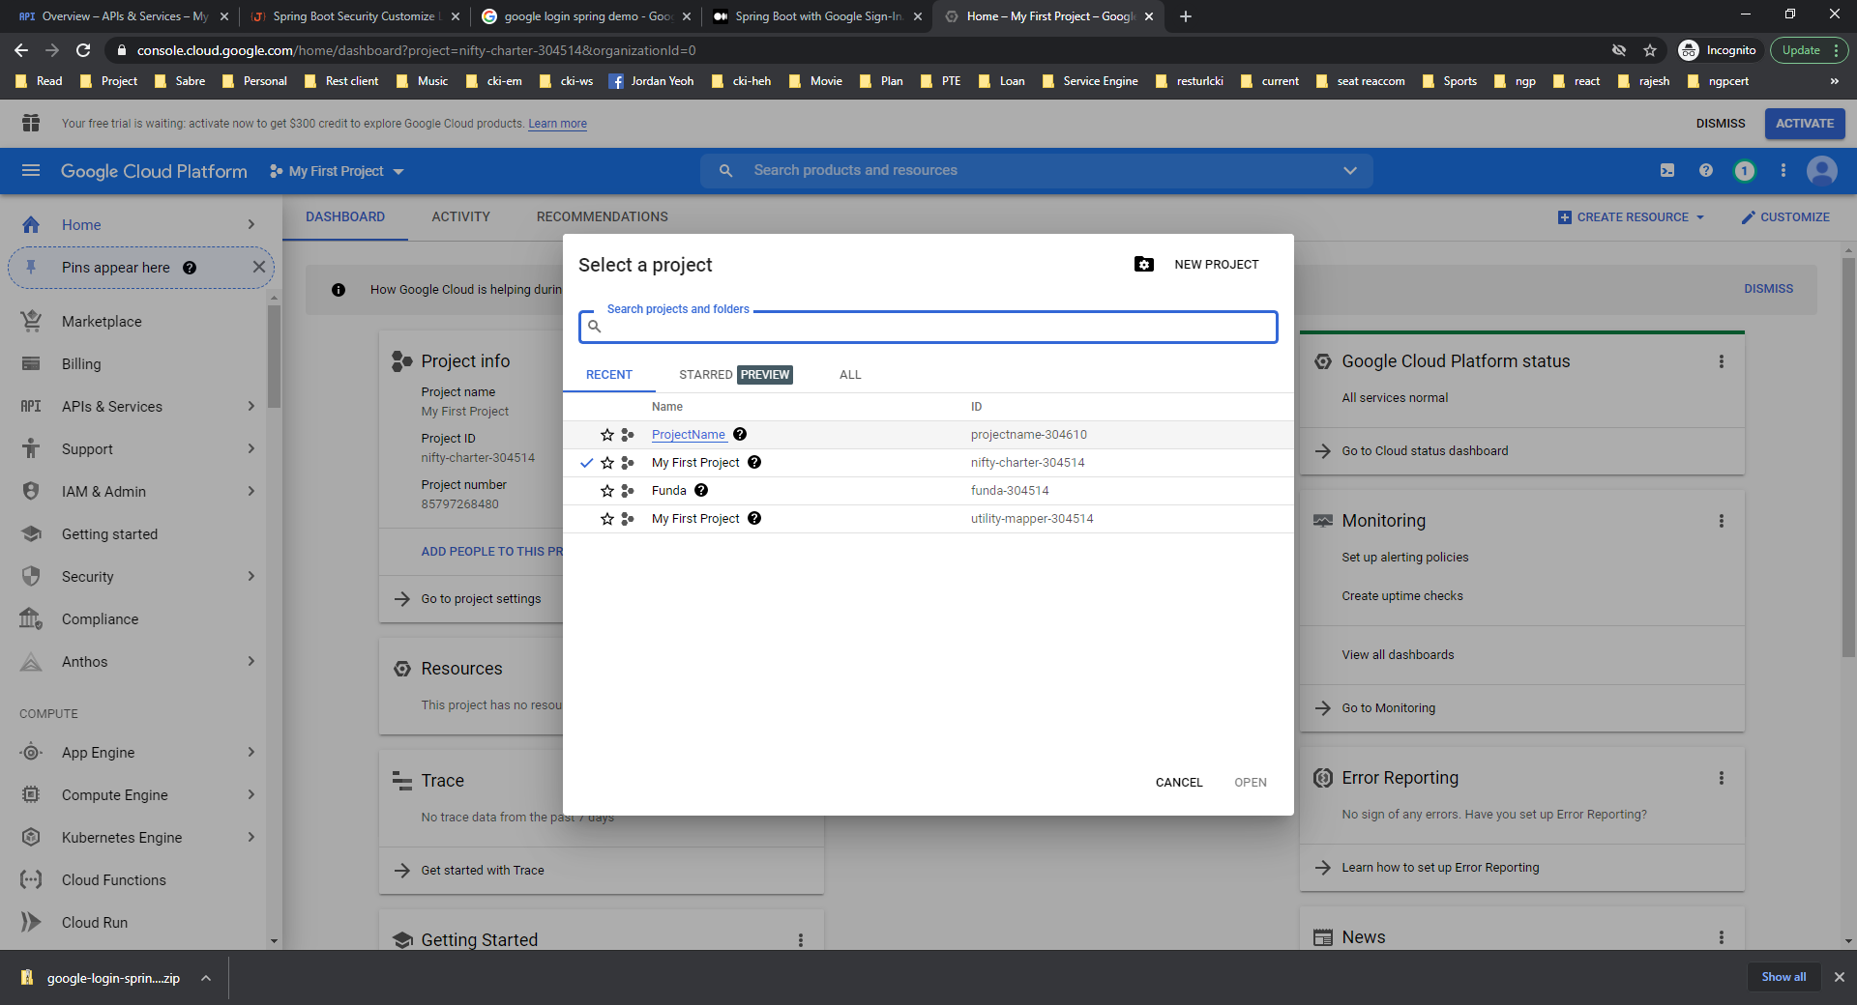



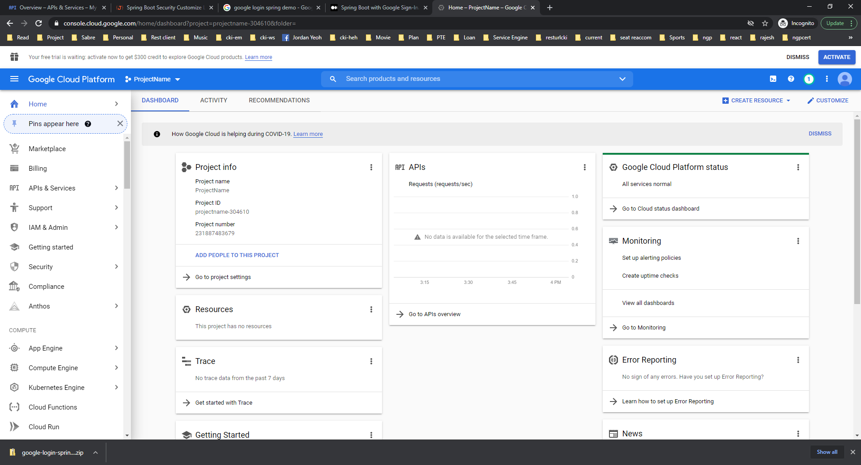



Then select Credentials under APIs and Services.

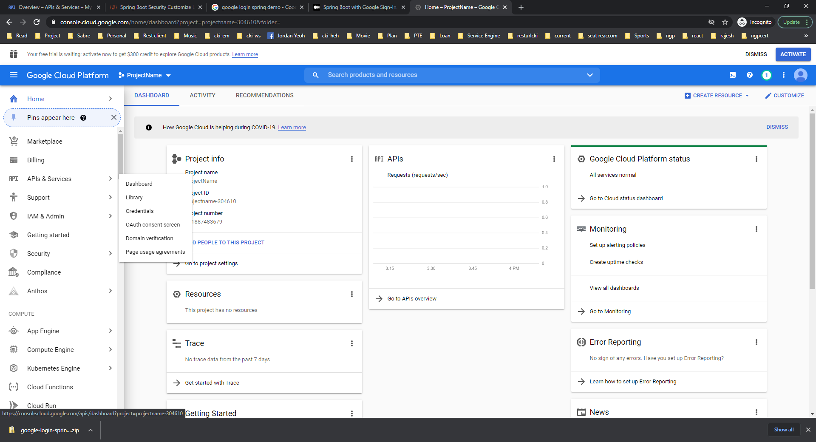



Click Create Credentials -> OAuth Client Id

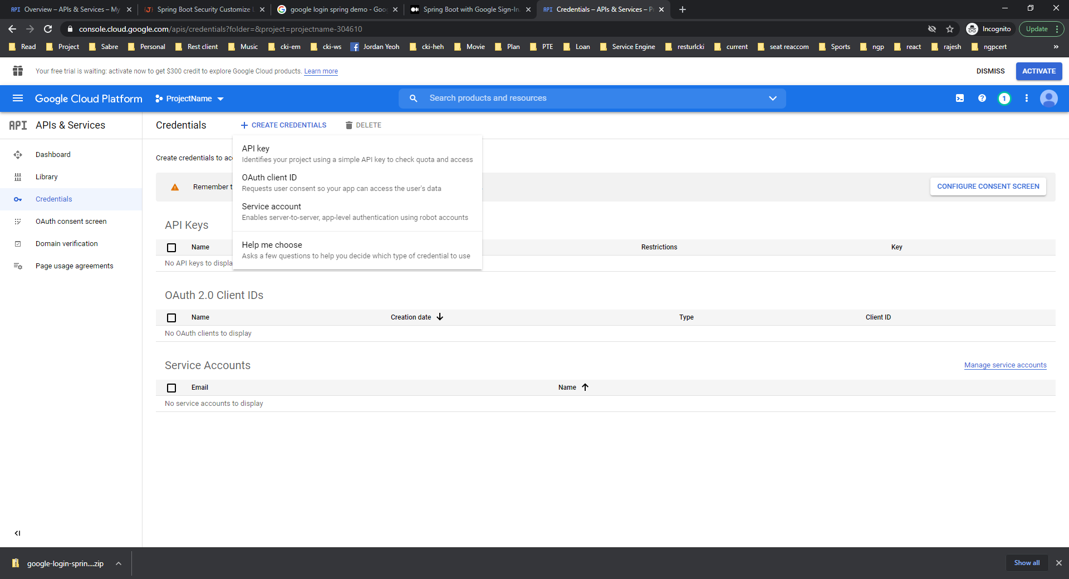



Select Configure Consent Screen

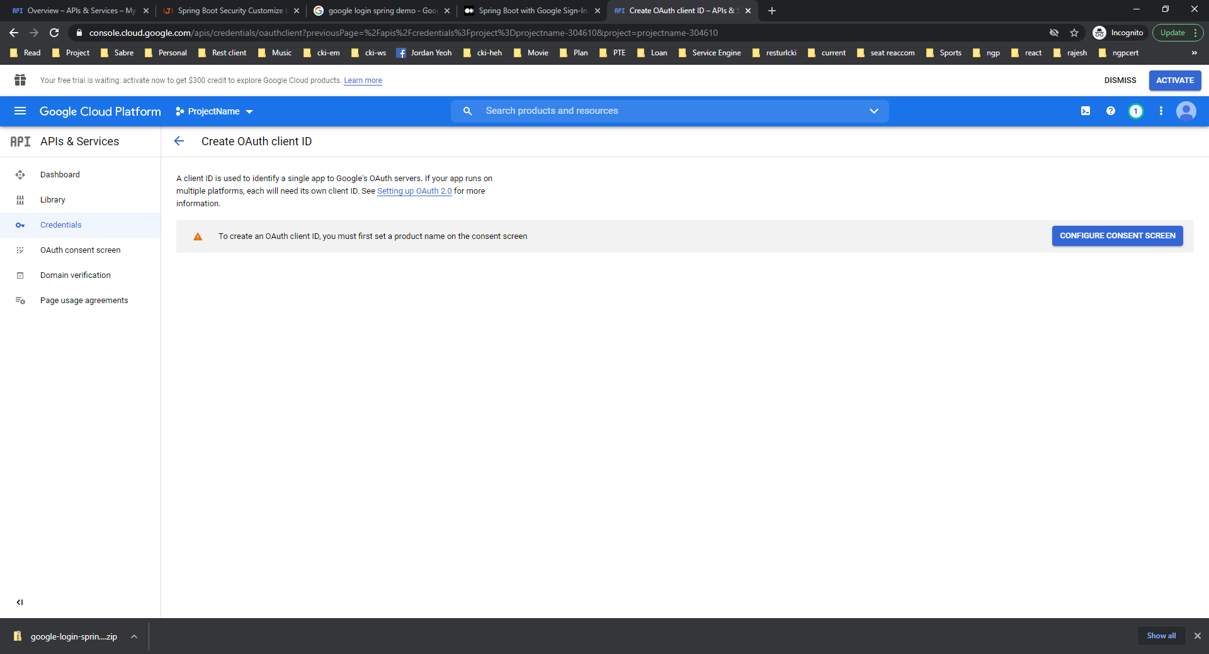



Select External and Create:

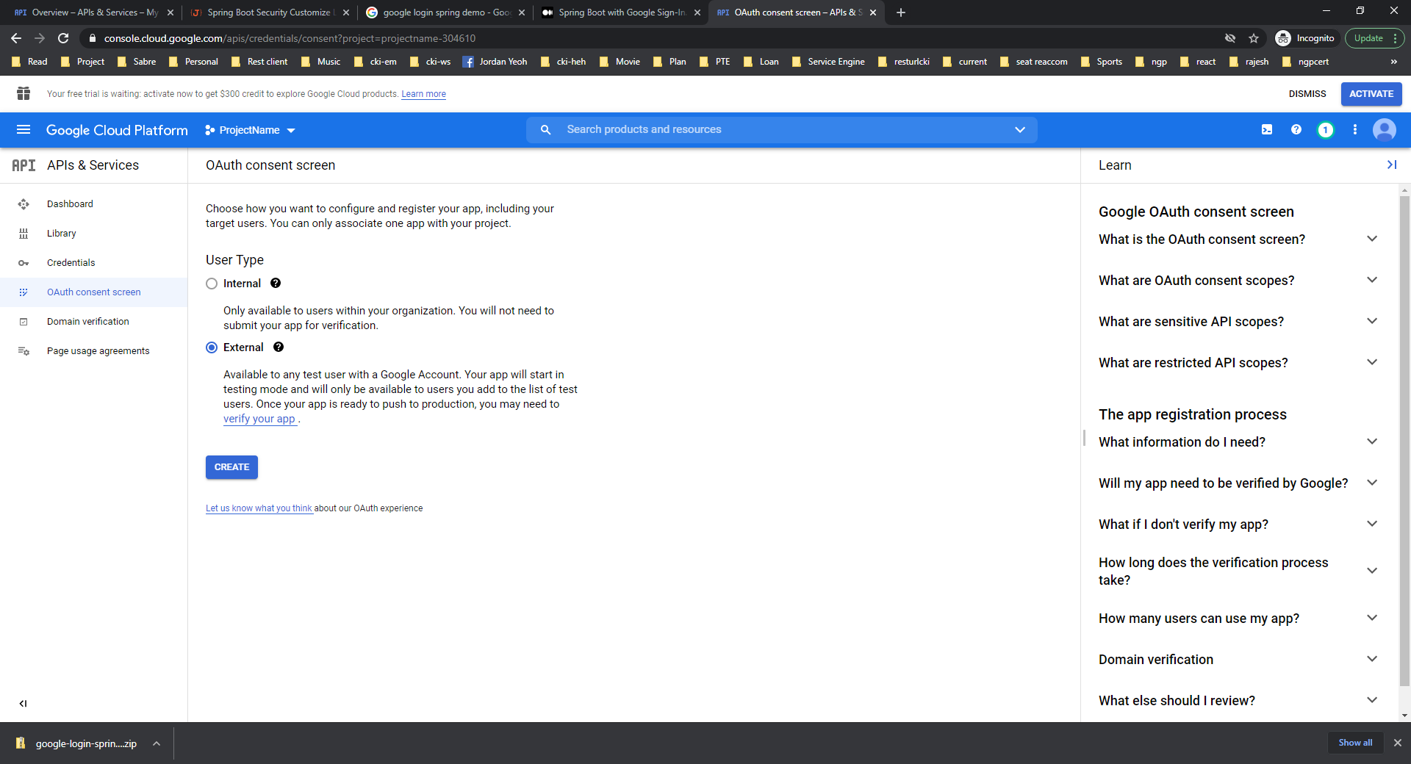



Fill The form like below screenshot with correct Application Name and contact mail id. Then Save Continue.

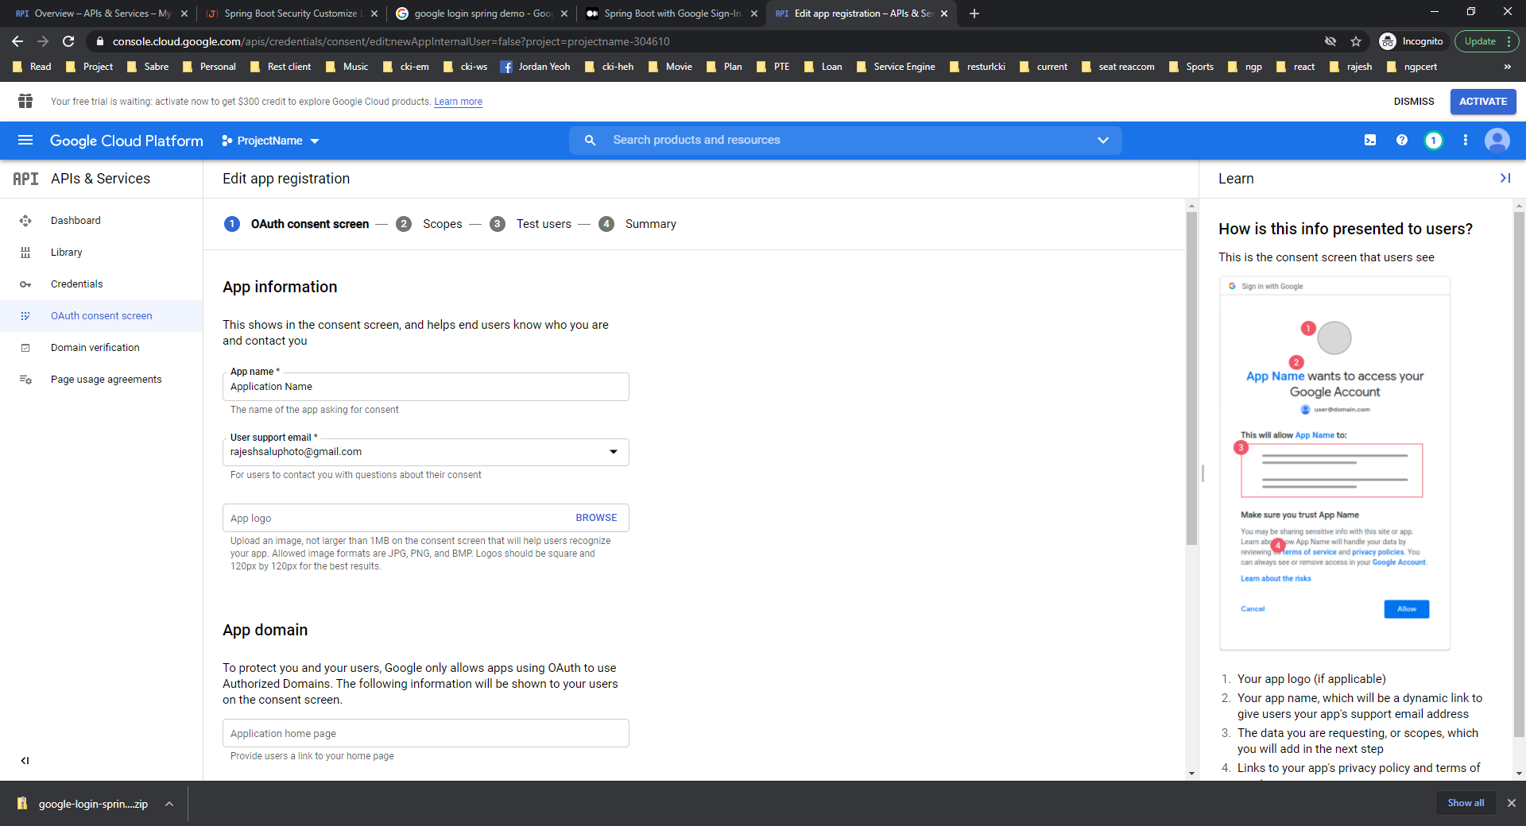



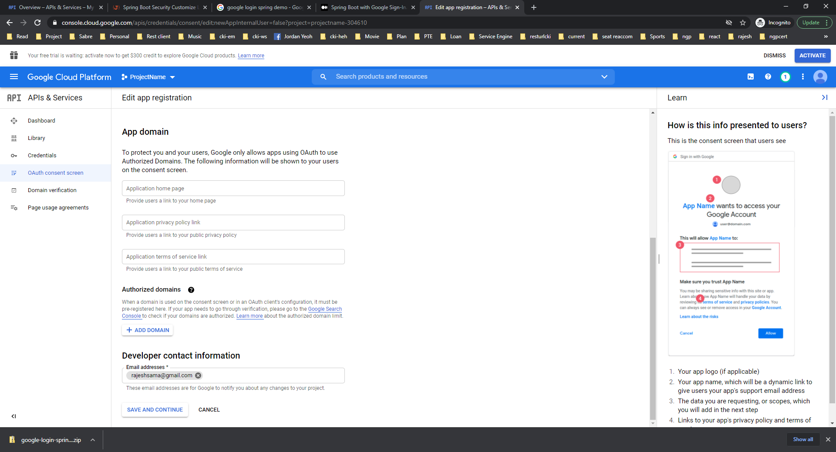



Then No changes Requires and click Save and Continue



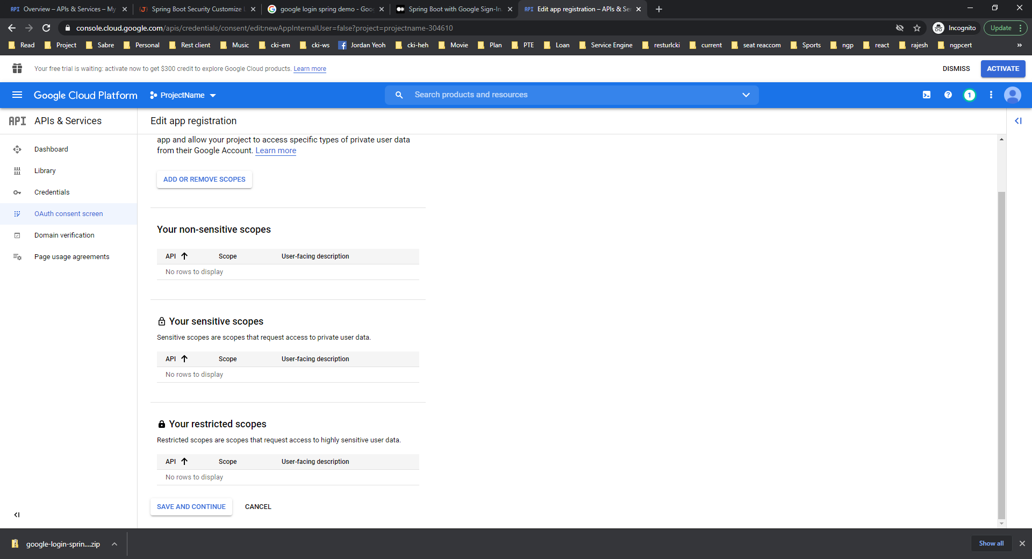



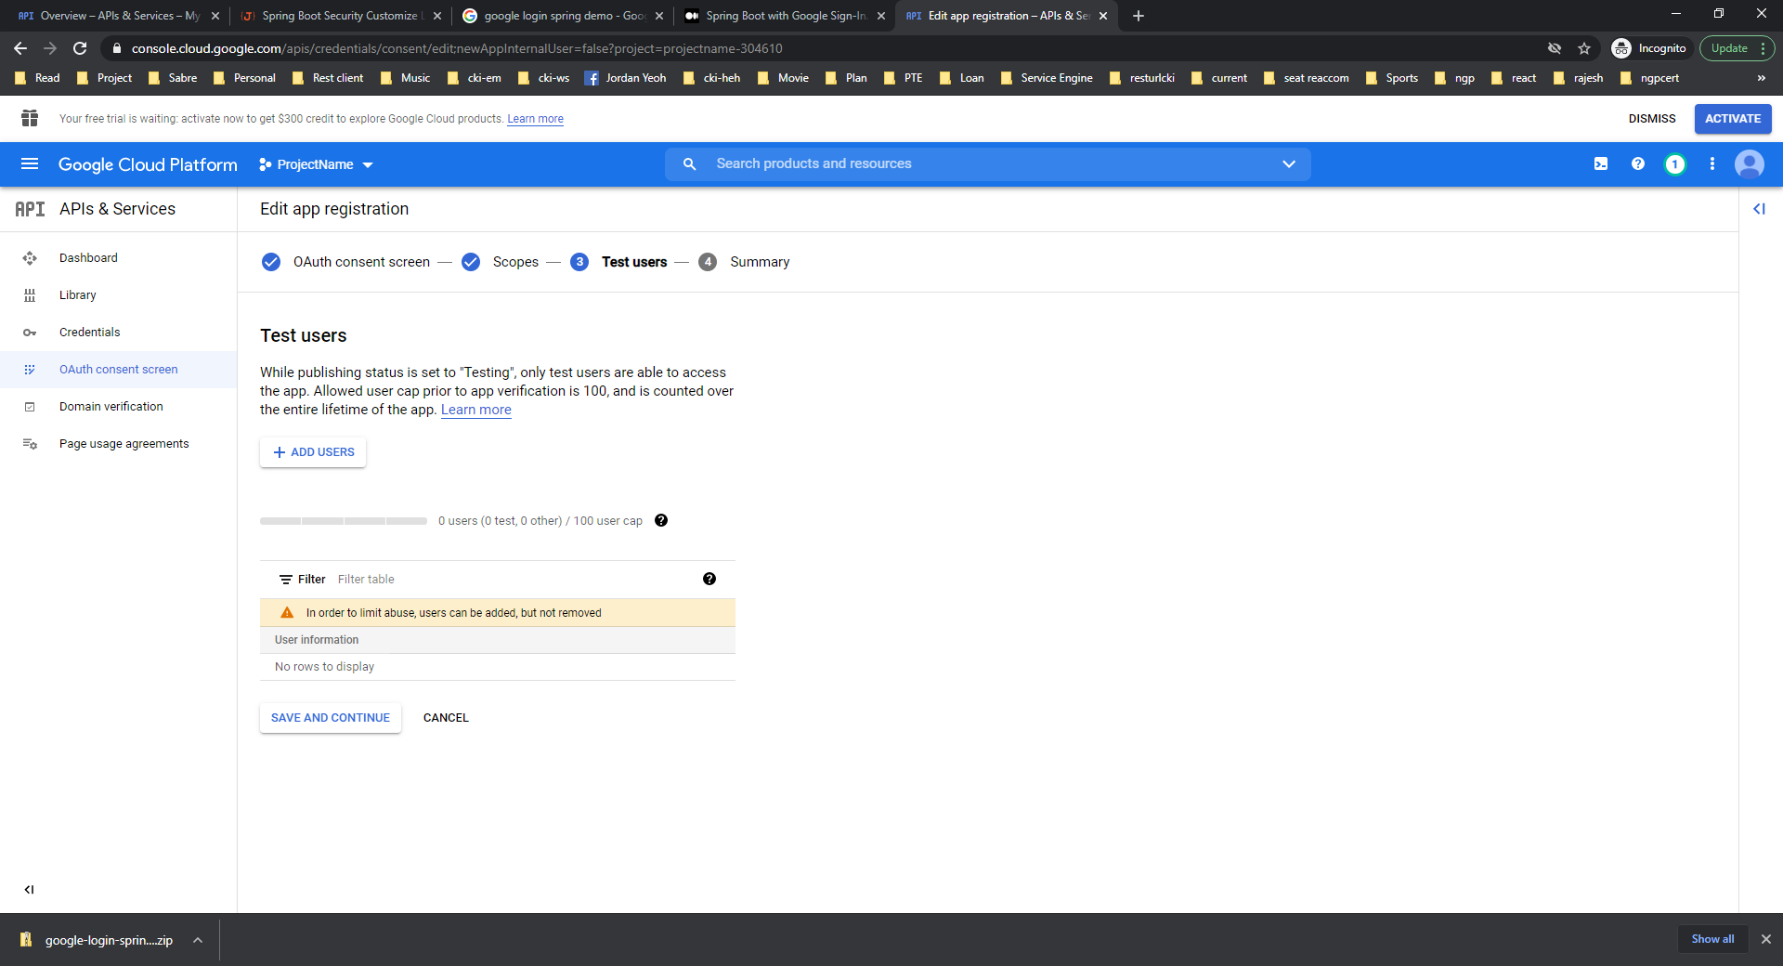



On Summary Screen, click Back To Dashboard.

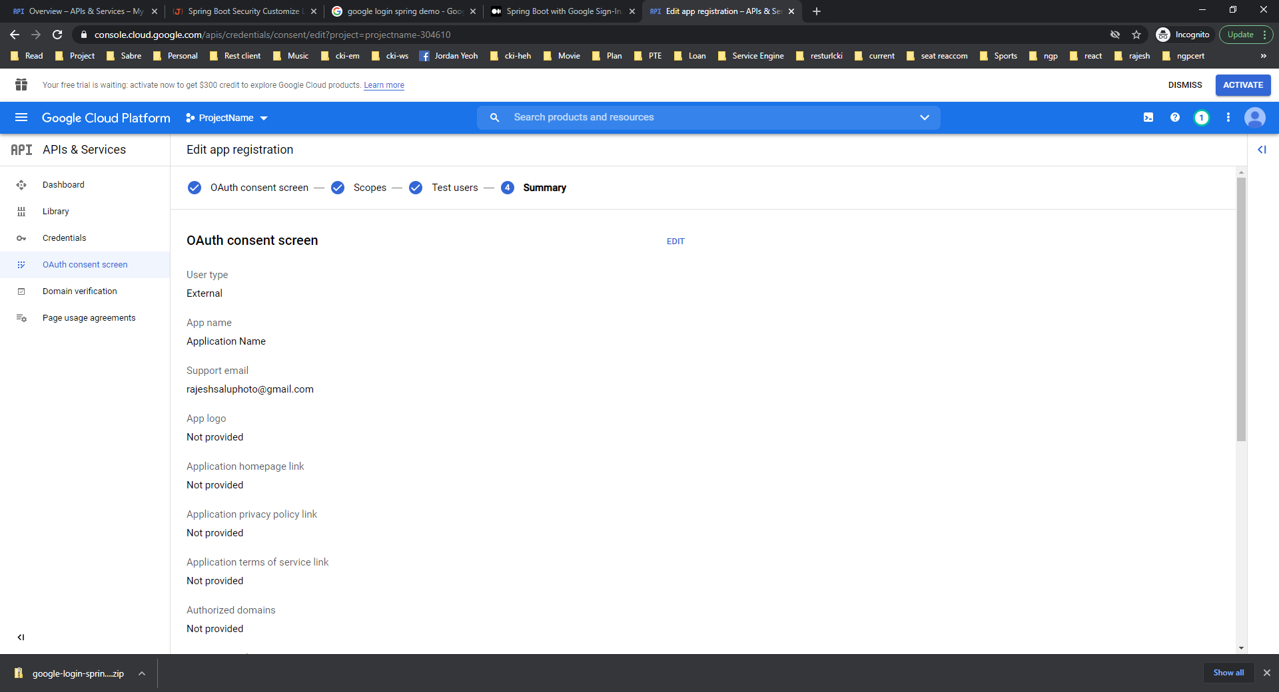



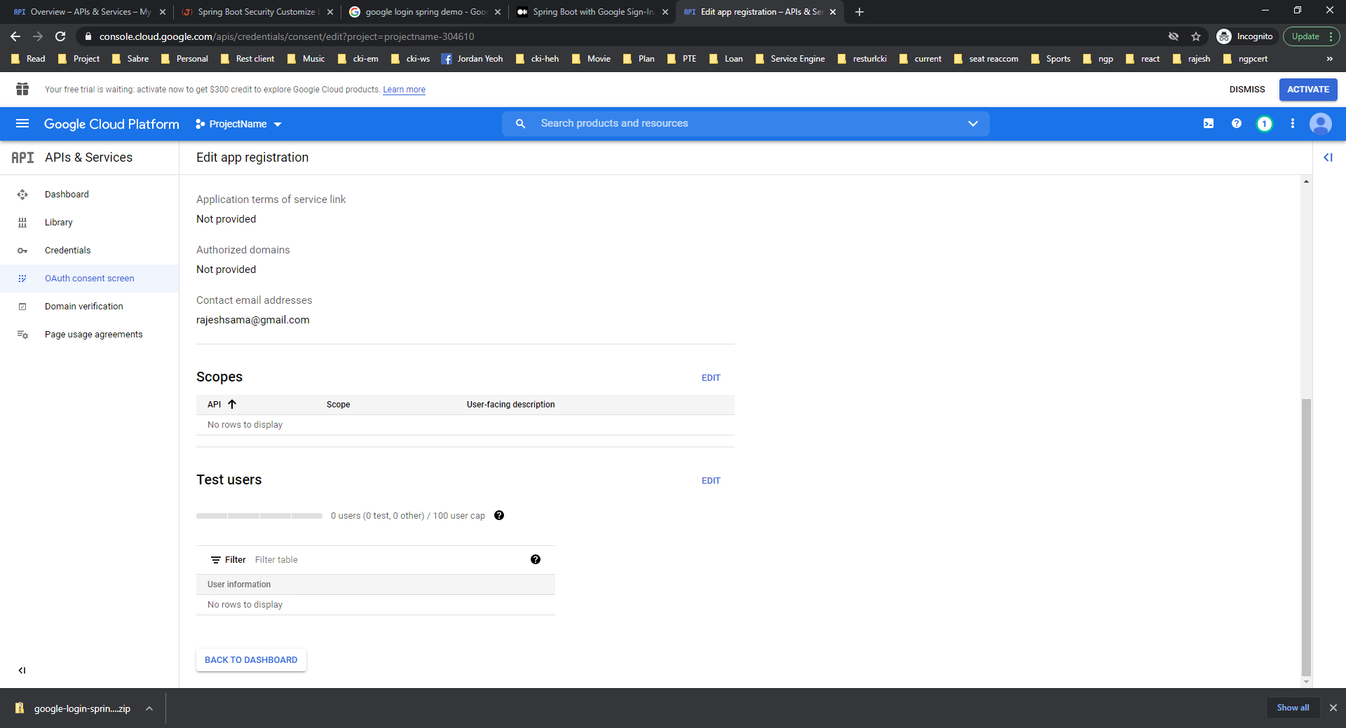



Then you will be redirect to OAuth Consent Screen. Now Publish the app.

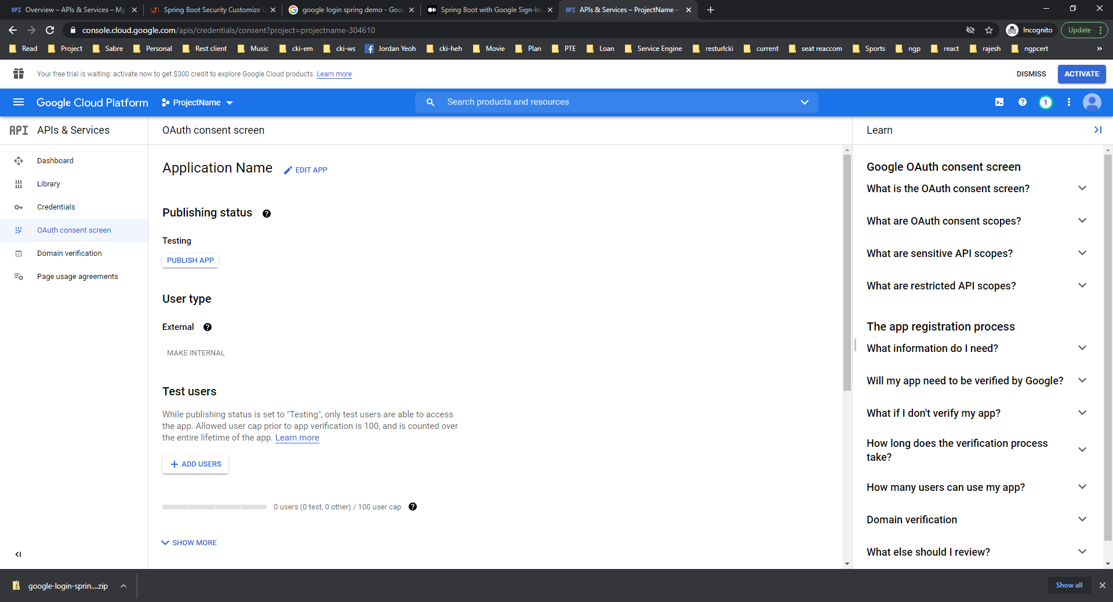



Again Click on Credentials.

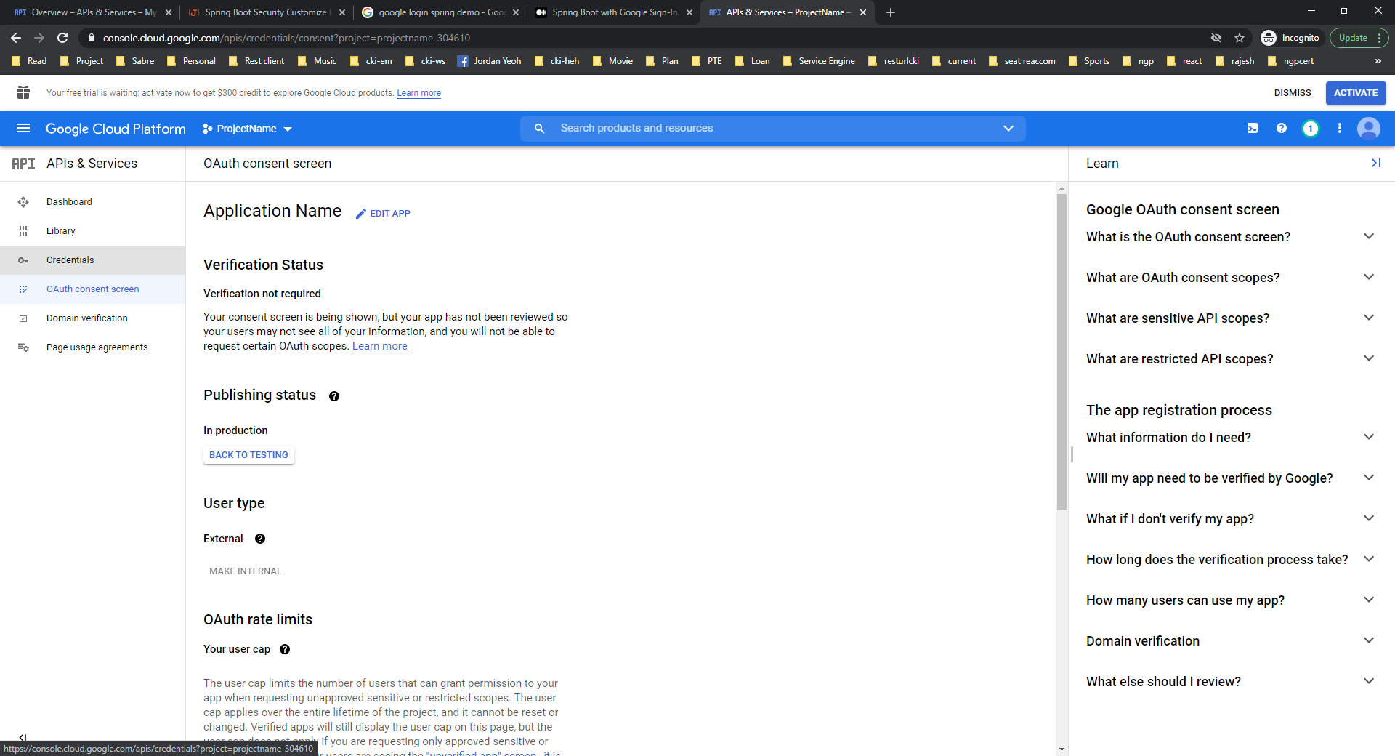



Click on Create Credentials.

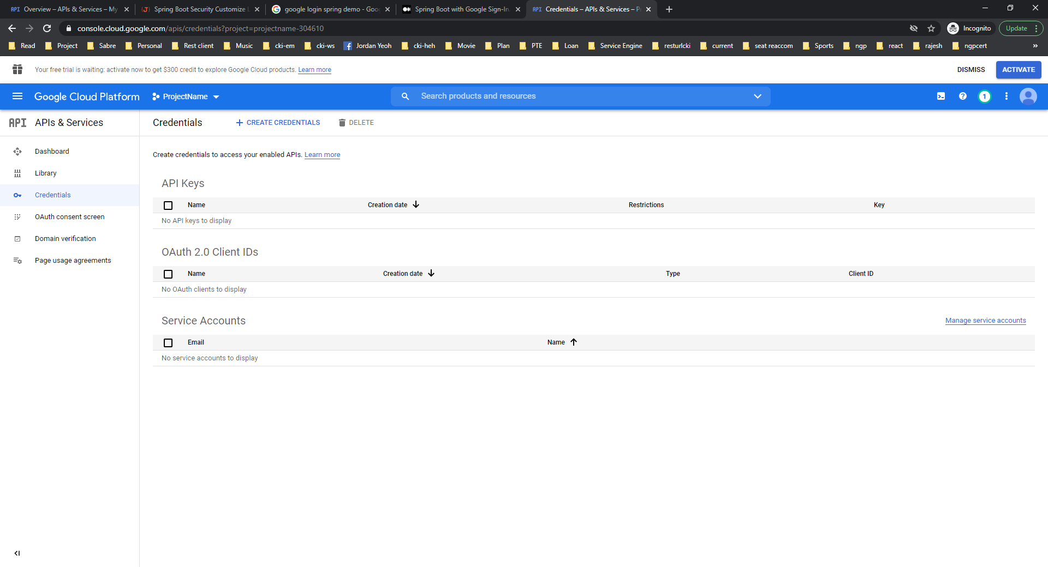



Select OAuth Client Id.

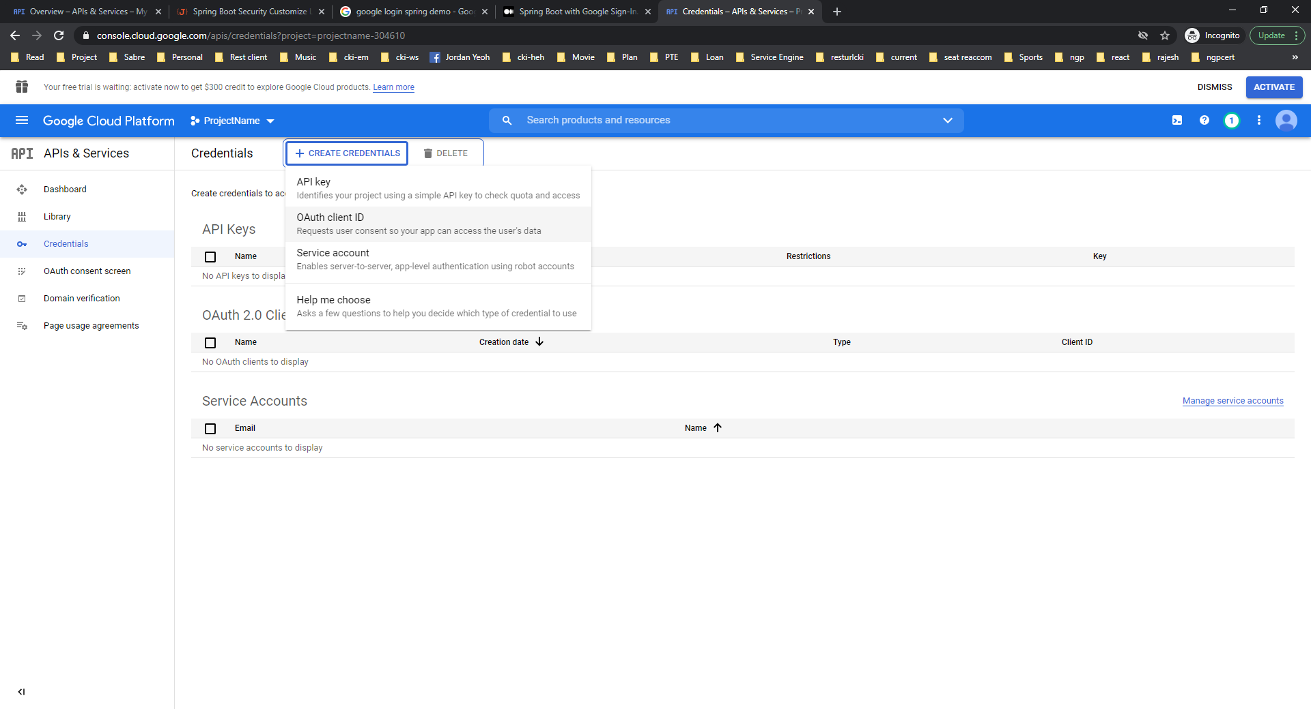



Select Application Type as Web Application and Application Name as per your application name.

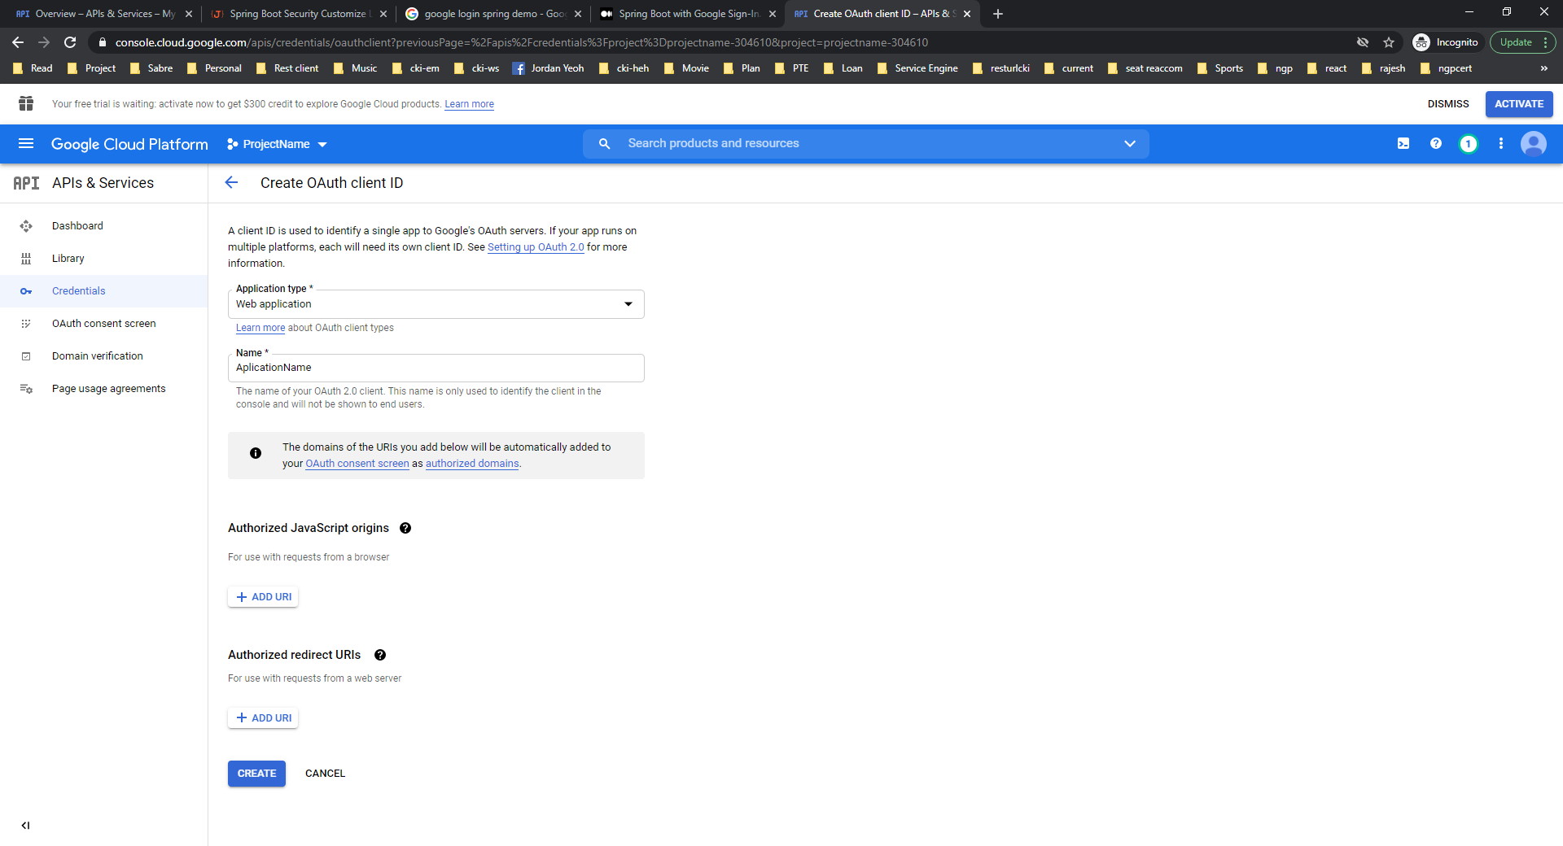



For Authorized javascript origins, authorized redirect URIs, <http://localhost:9080>, <http://localhost:9080/login/oauth2/code/google> mentioned in screenshot.

If production website is <http://facebook.com> then replace , <http://localhost:9080> with <http://facebook.com> in both url.

/login/oauth2/code/google should be appended to <http://facebook.com> in authorized redirect URIs.

Then click Create.

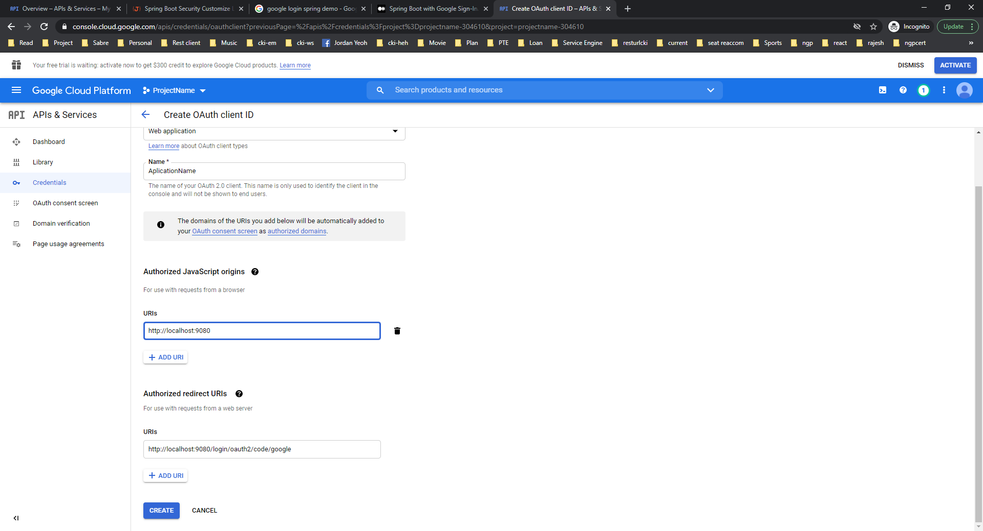



Now you have client id and client secret.

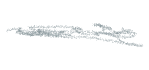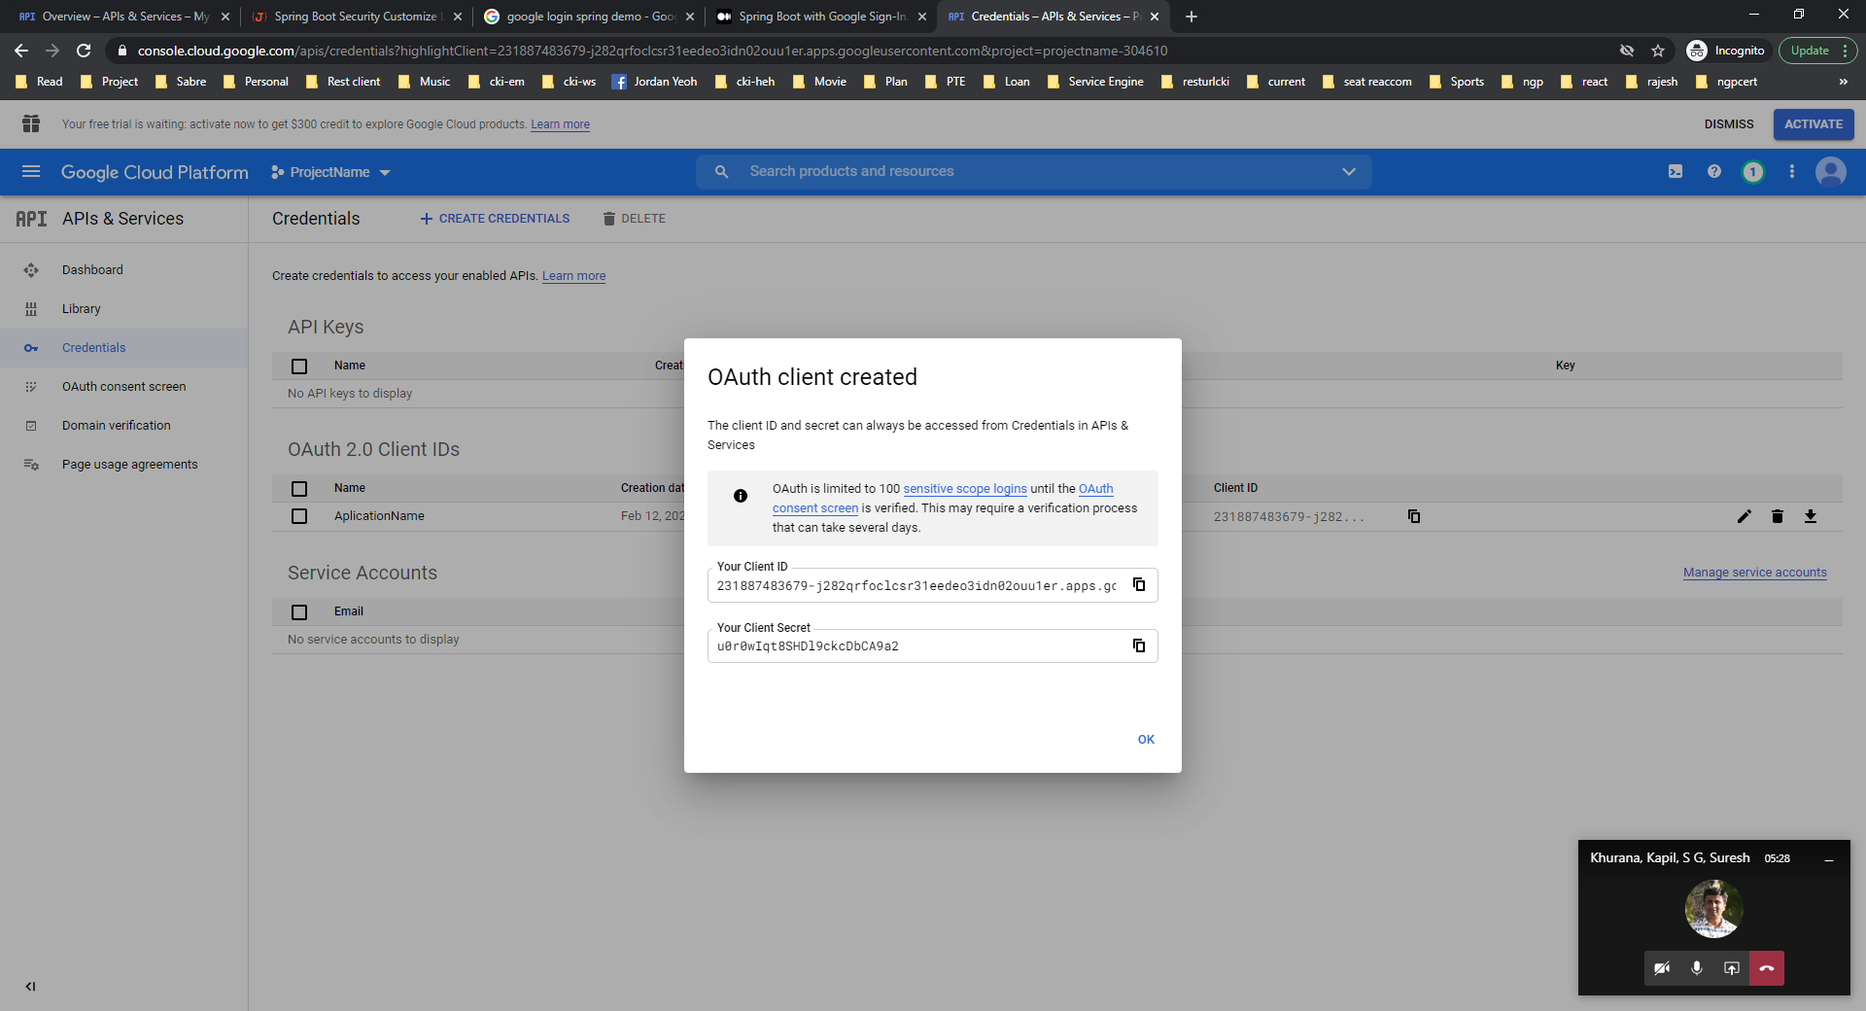



**Facebook Client Id and Client Secret Creation:**

Login to <https://developers.facebook.com/> and then Click on **My Apps**



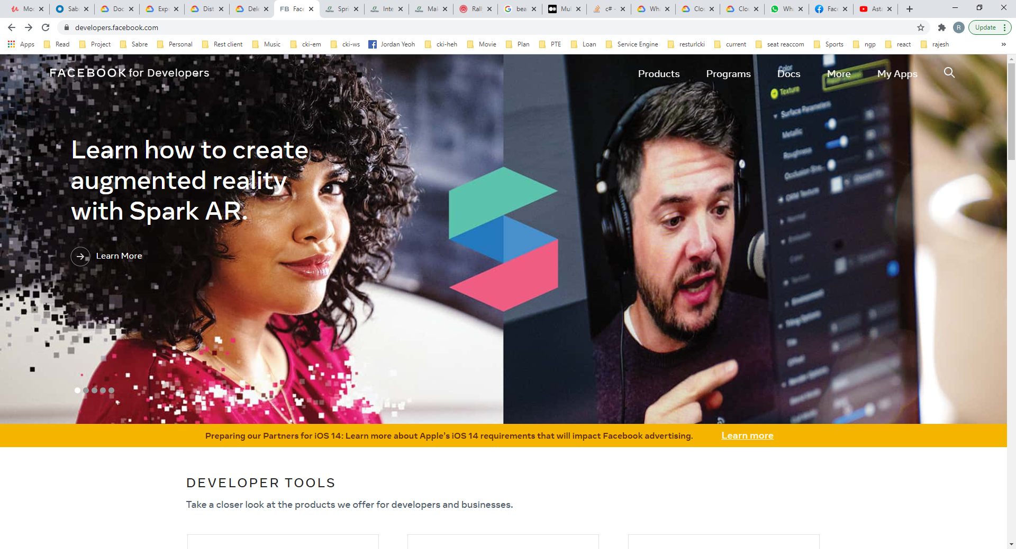



Click on Create APP.

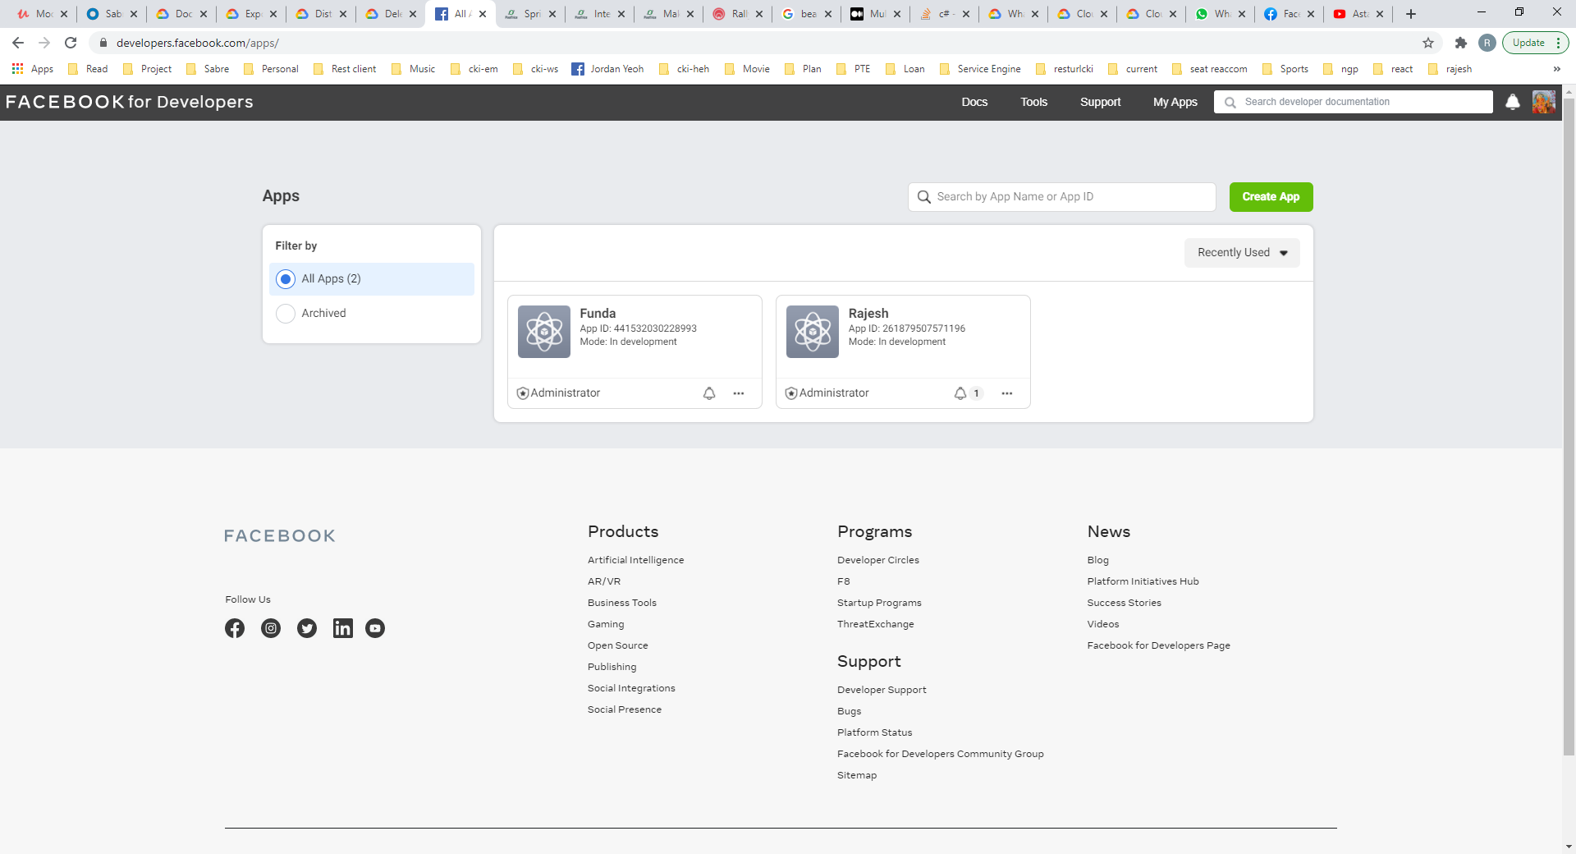



Click on More options Then Continue.

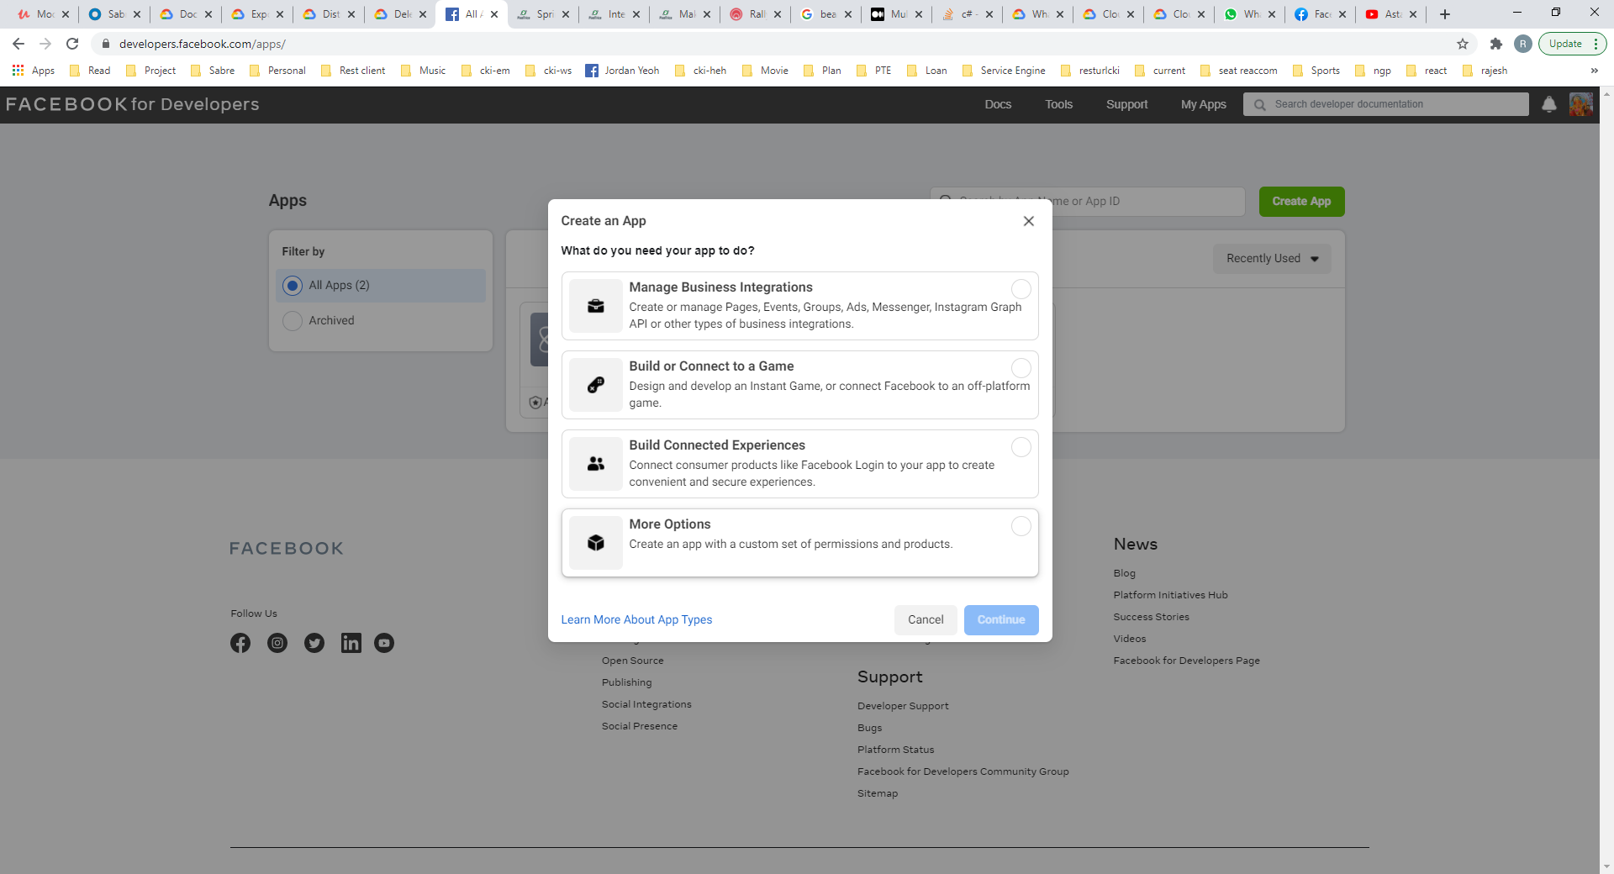



Click On Something Else and Continue.

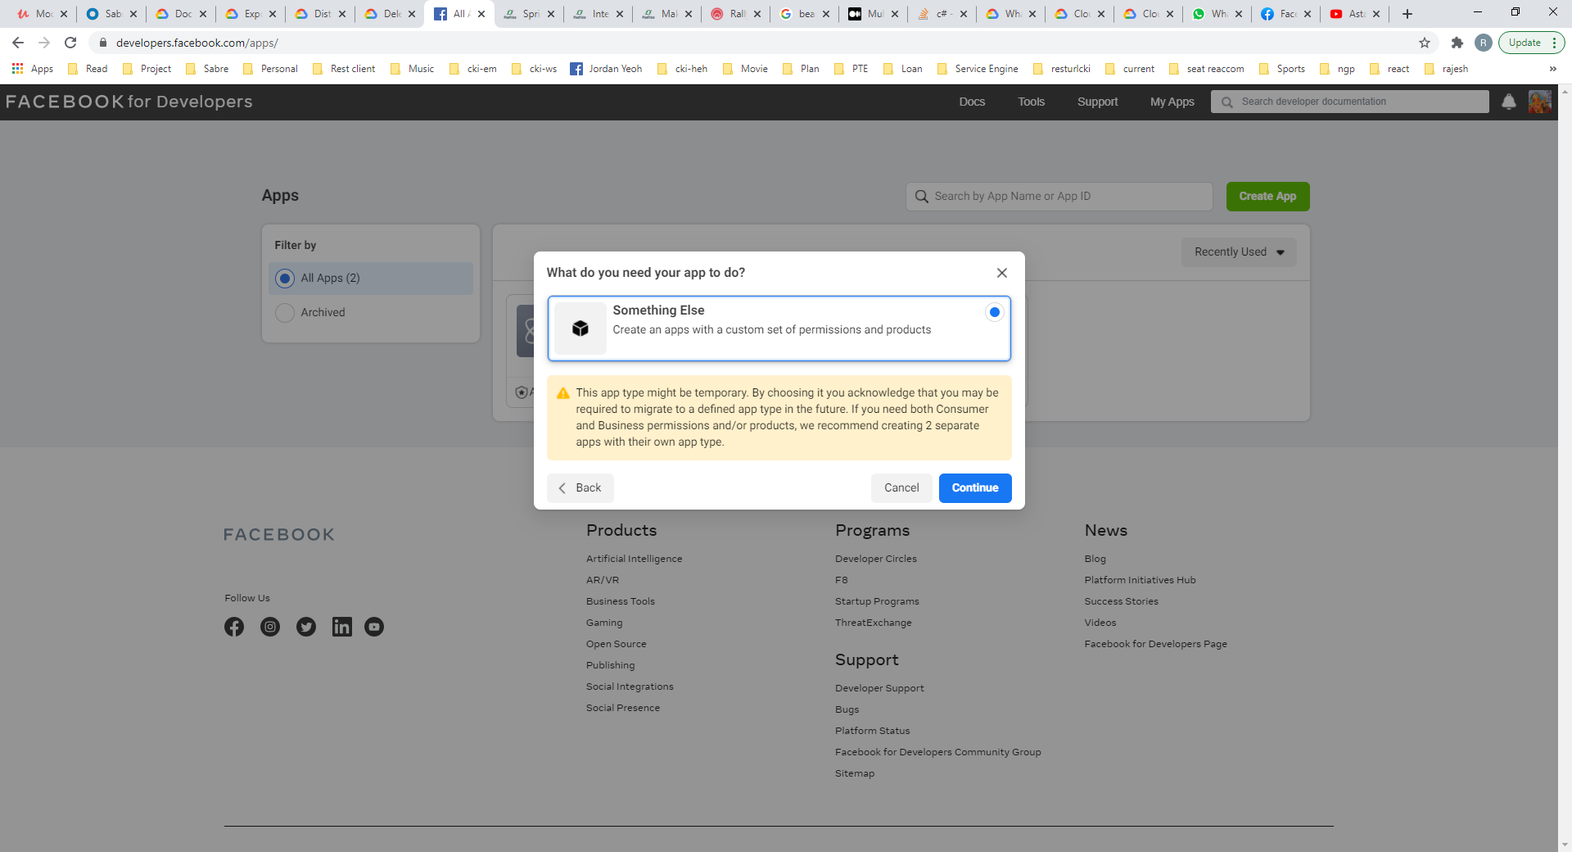



Add App Display Name and Then Create APP.

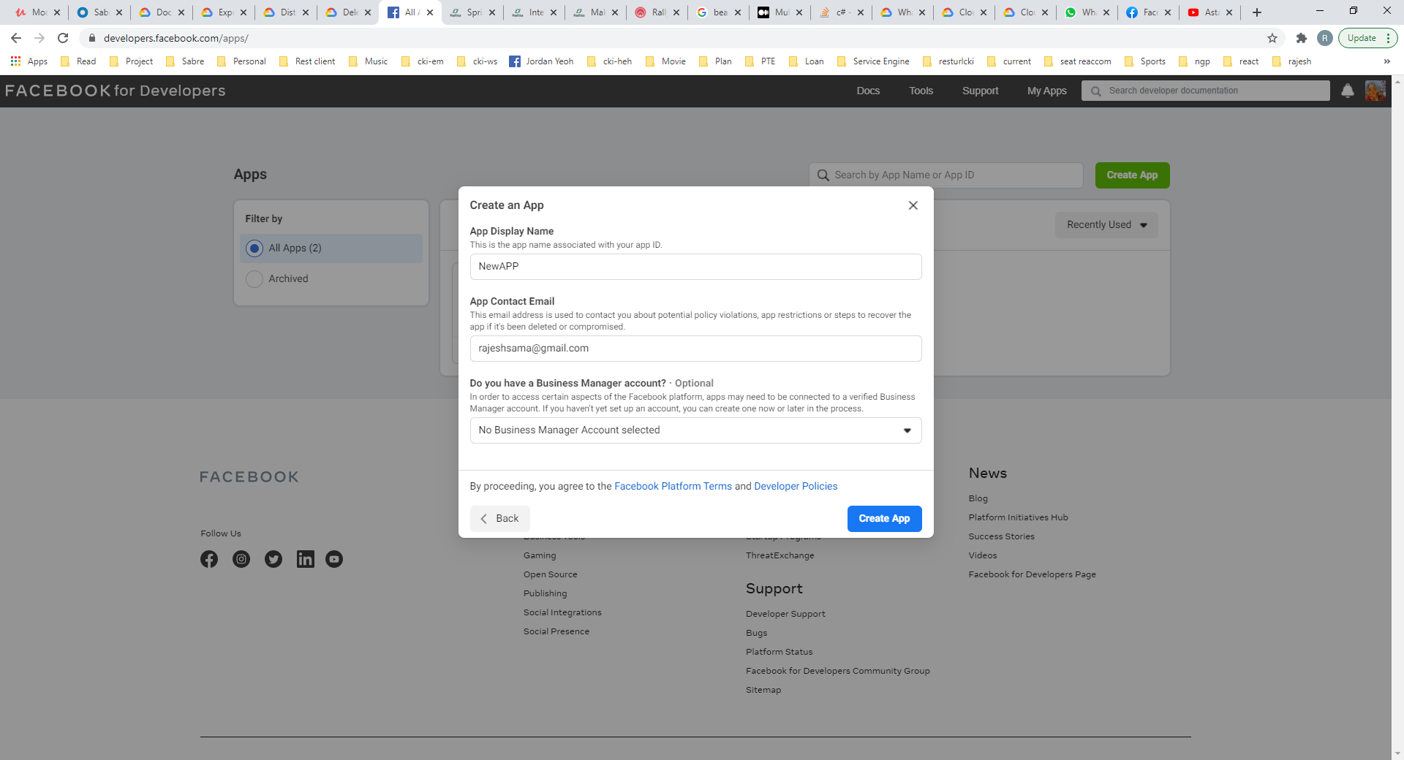



Complete Security Check and Submit.

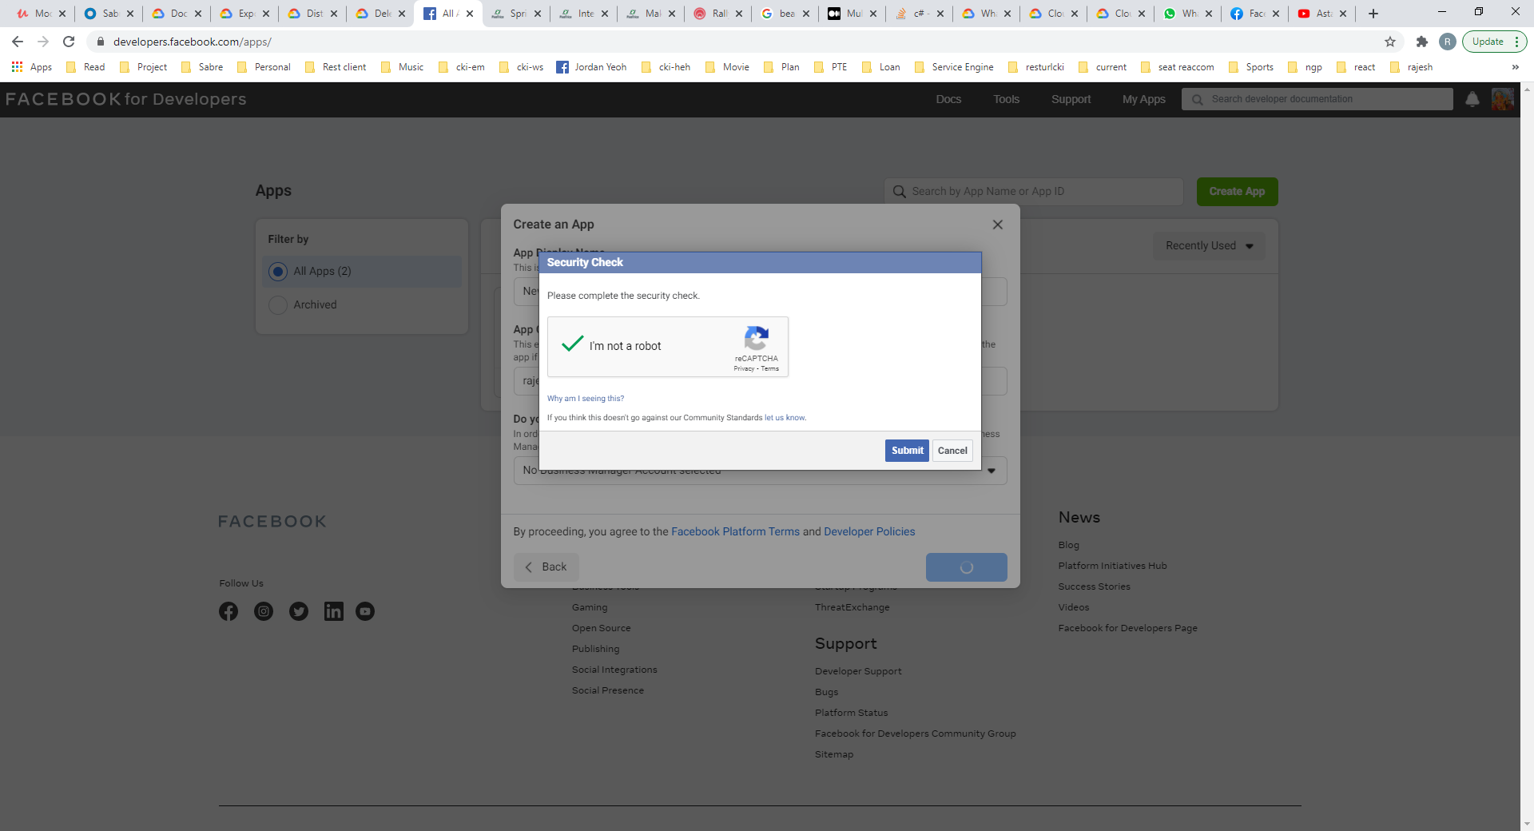



Now You will be in your App page.

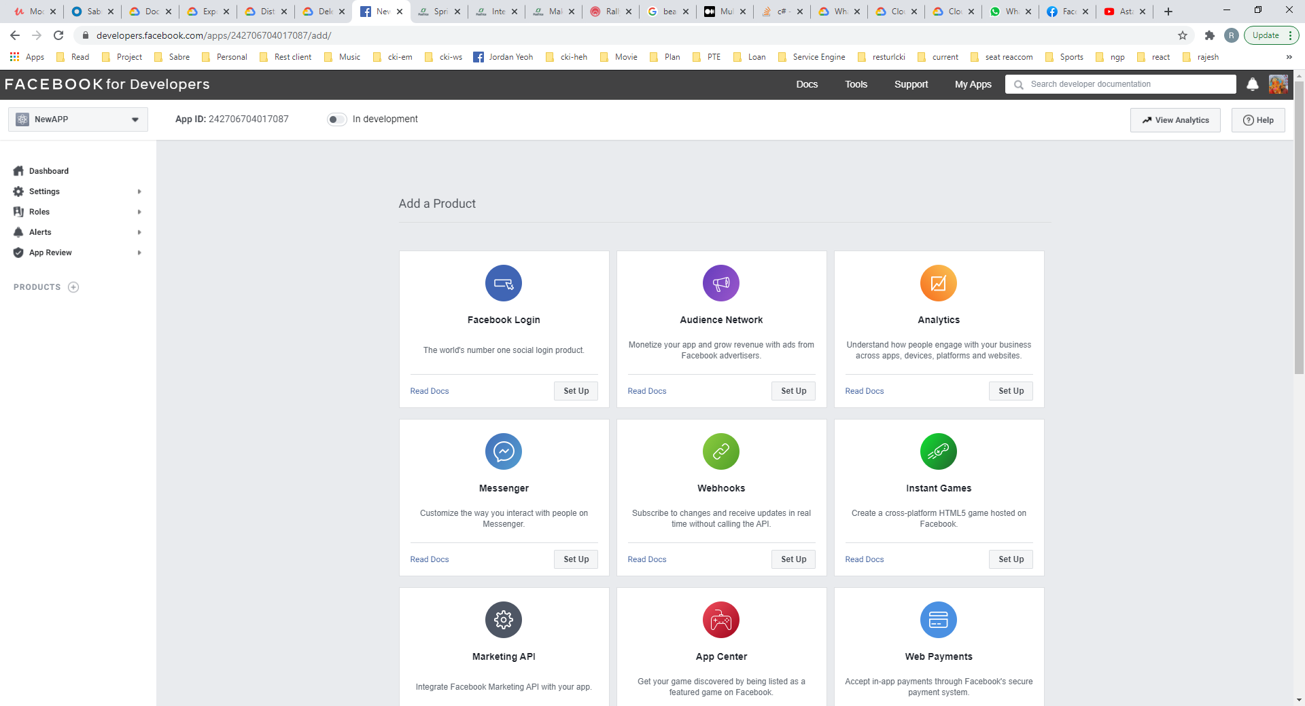



Goto Settings -> Basic, click on show to see App Secret. It will ask to give your facebook password.

